**ASSIGNMENT-2**

**STUDENT INFORMATION SYSTEM**

**TASK-1**

**1.Creation of database**

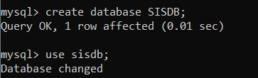

**3.ERD diagram**

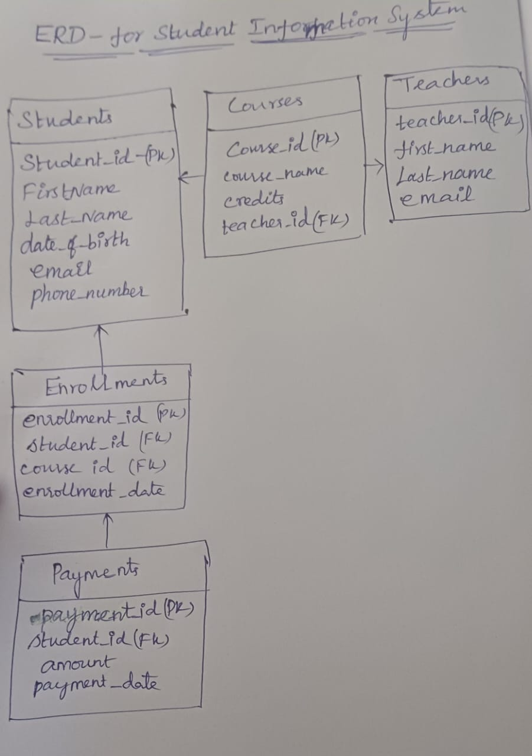

**2.Define schema for students, Courses, enrollments, Teacher and payments**

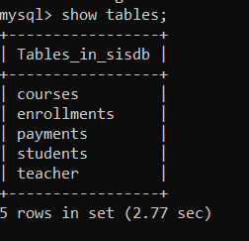

**4.Createappropriate primary and foreign key**

Student_Id int primary key

teacher_id int primary key

course_id int primary key

enrollment_id int primary key

foreign key(student_id) references Students(student_id)

foreign key(student_id) references Students(student_id),

foreign key (course_id) references Courses(course_id));

Create student table

create table Students (Student_Id int primary key,first_Name text ,last_Name text,date_of_birth date,Email text,phone_number text);

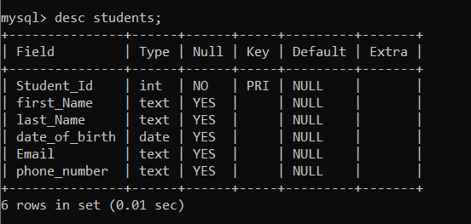

Create the Teacher table

create table Teacher (teacher_id int primary key, first_name varchar(20) ,last_name varchar(20) ,email varchar(100));

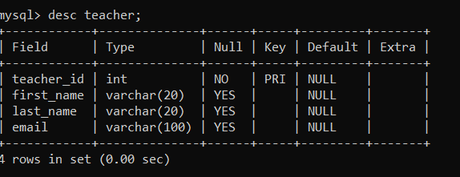

Create the Courses table

create table Courses (course_id int primary key,course_name varchar(50),credits int,teacher_id int,foreign key (teacher_id) references Teacher(teacher_id));

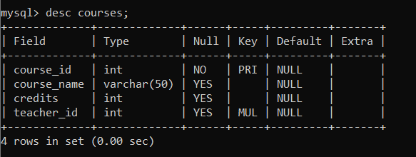

Create the Enrollments table

CREATE TABLE Enrollments (enrollment_id int primary key,student_id int,course_id int,enrollment_date date,foreign key(student_id) references Students(student_id),foreign key (course_id) references Courses(course_id));

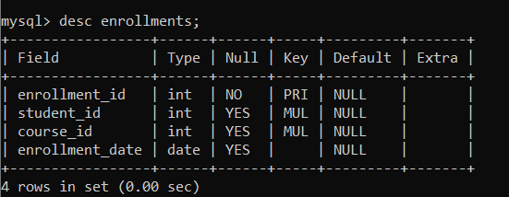

Create the Payments table

create table Payments (payment_id INT PRIMARY KEY,student_id INT,amount DECIMAL(10, 2),payment_date DATE,foreign key (student_id) references Students(student_id));

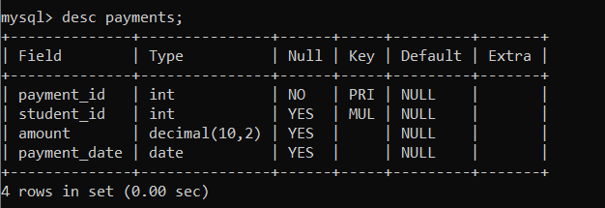

**5.Insert values into the tables**

insert into Students table

insert into Students values

(1, 'Aarav',' Patel','1999-07-02', 'aarav.patel@example.com', '9876543210'),

(2, 'Isha',' Singh','2000-05-09', 'isha.singh@example.com', '9786543210'),

(3, 'Aryan ','Reddy','2001-09-08', 'aryan.reddy@example.com', '9087654321'),

(4, 'Ananya',' Kumar','2000-02-07', 'ananya.kumar@example.com', '8907654321'),

(5, 'Sneha', ' Sharma','2000-11-04', 'sneha.sharma@example.com', '9776543210'),

(6, 'Rahul',' Kapoor','1998-12-08','rahul.kapoor@example.com', '9087645321'),

(7, 'Divya',' Verma','1998-06-16', 'divya.verma@example.com', '9123456780'),

(8, 'Rohan',' Gupta','1995-09-01', 'rohan.gupta@example.com', '9213456780'),

(9, 'Neha',' Rajput','1999-03-28','neha.rajput@example.com', '9087123465'),

(10, 'Vivek ','Joshi','2000-01-03', 'vivek.joshi@example.com', '9021435687');

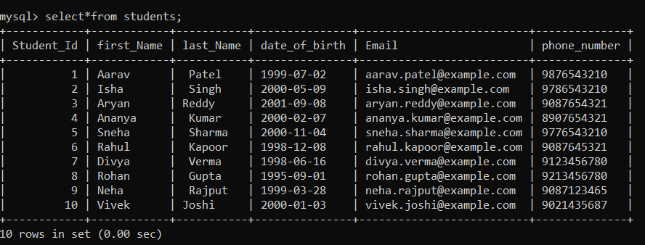

insert into Teacher values

(1, 'Anjali', 'Mishra', 'anjali.mishra@example.com'),

(2, 'Vikram', 'Singh', 'vikram.singh@example.com'),

(3, 'Sneha', 'Gupta', 'sneha.gupta@example.com'),

(4, 'Amit', 'Sharma', 'amit.sharma@example.com'),

(5, 'Pooja', 'Verma', 'pooja.verma@example.com'),

(6, 'Rajat', 'Singh', 'rajat.singh@example.com'),

(7, 'Anita', 'Yadav', 'anita.yadav@example.com'),

(8, 'Vikrant', 'Mehra', 'vikrant.mehra@example.com'),

(9, 'Preeti', 'Sinha', 'preeti.sinha@example.com'),

(10, 'Aditya', 'Verma', 'aditya.verma@example.com');

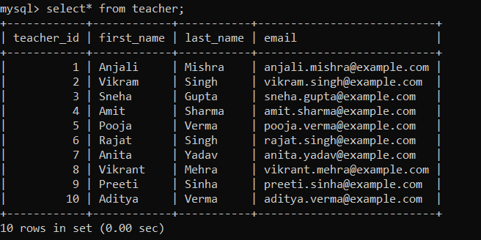

insert into Courses values

(101, 'Computer Science', 4, 1),

(102, 'Mathematics', 3, 2),

(103, 'Physics', 3, 3),

(104, 'Chemistry', 4, 4),

(105, 'Biology', 3, 5),

(106, 'History', 3, 6),

(107, 'Economics', 4, 7),

(108, 'Psychology', 3, 8),

(109, 'Music', 4, 9),

(110, 'Art', 3, 10);

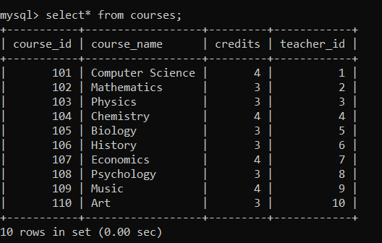

insert into Enrollments values

(201, 1, 101, '2023-01-15'),

(202, 2, 102, '2023-01-20'),

(203, 3, 103, '2023-01-25'),

(204, 4, 104, '2023-03-15'),

(205, 5, 105, '2023-03-20'),

(206, 6, 106, '2023-03-25'),

(207, 7, 107, '2023-04-01'),

(208, 8, 108, '2023-04-05'),

(209, 9, 109, '2023-05-15'),

(210, 10, 110, '2023-05-20');

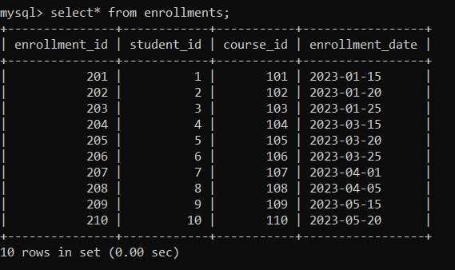

insert into Payments values

(301, 1, 1000.00, '2023-02-01'),

(302, 2, 1200.00, '2023-02-05'),

(303, 3, 800.00, '2023-02-10'),

(304, 4, 1200.00, '2023-04-10'),

(305, 5, 1000.00, '2023-04-15'),

(306, 6, 800.00, '2023-04-20'),

(307, 7, 1500.00, '2023-04-25'),

(308, 8, 1300.00, '2023-05-01'),

(309, 9, 1200.00, '2023-06-10'),

(310, 10, 1000.00, '2023-06-15');

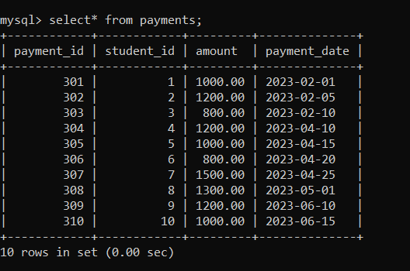

**TASK-2**

1.Insert a new student

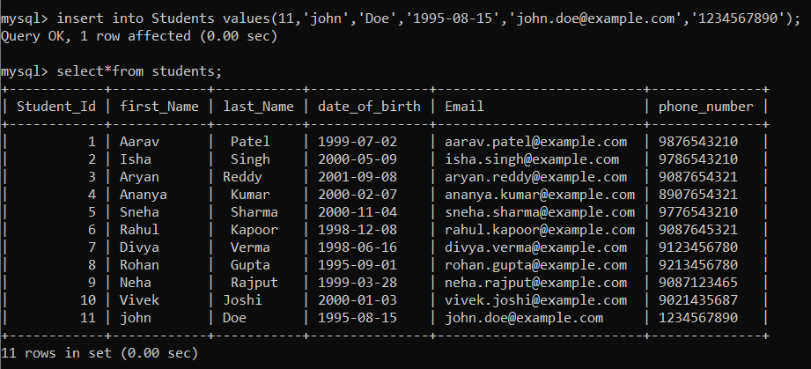

2.Enroll a student in a course

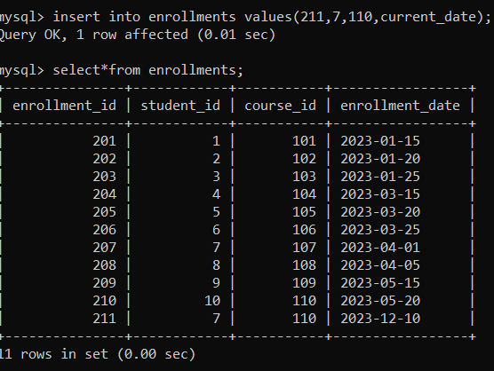

3.update email id of a specific teacher

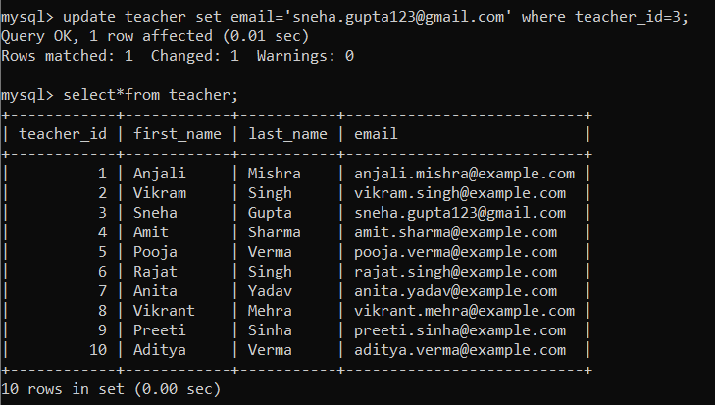

4.delete a specific enrollment record

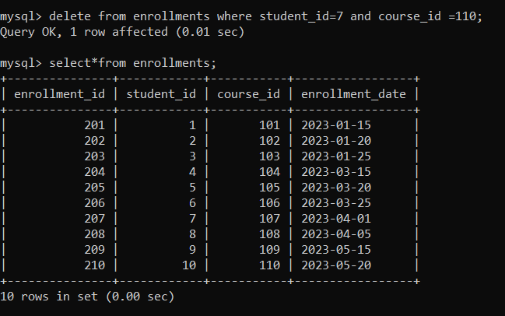

5.update course table to assign a specific teacher

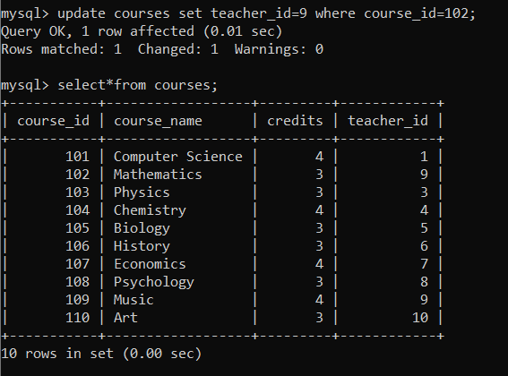

6. Delete a specific student from the "Students" table and remove all their enrollment records

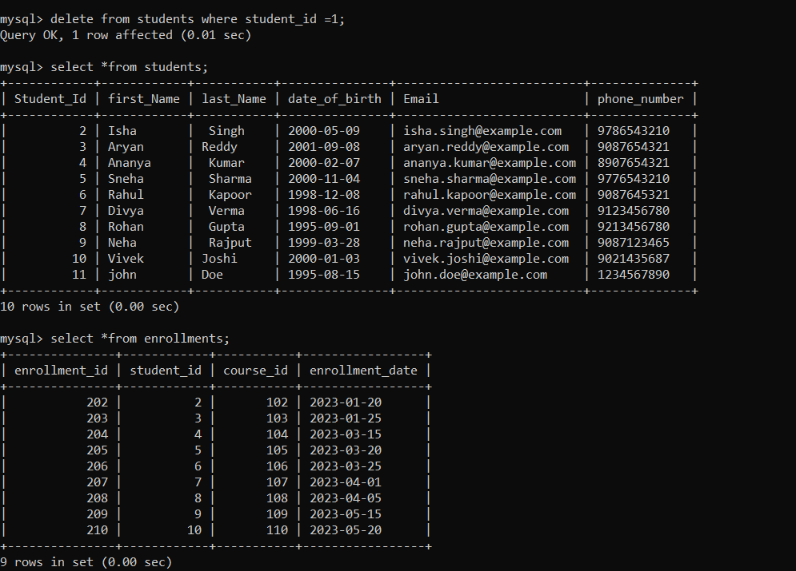

7.update the payment amount in payment table

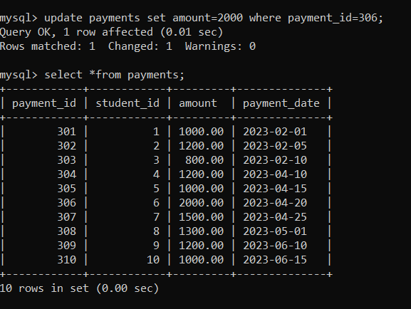

TASK 3

1. Calculate the total payments made by a specific student. You will need to join the "Payments" table with the "Students" table based on the student's ID.

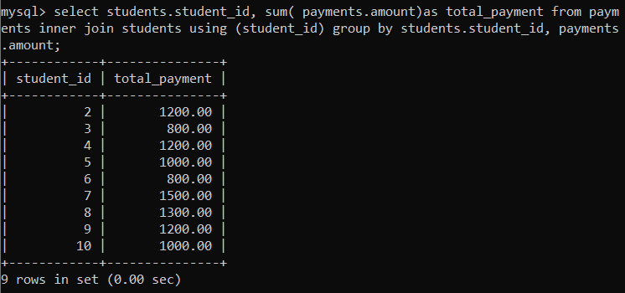

2. retrieve a list of courses along with the count of students enrolled in each course

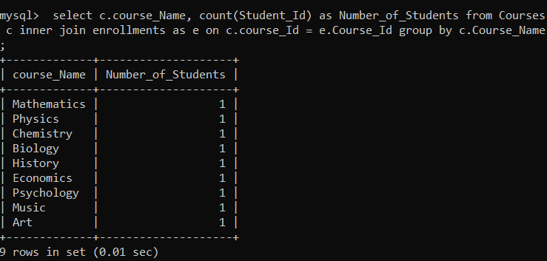

3. find the names of students who have not enrolled in any course.

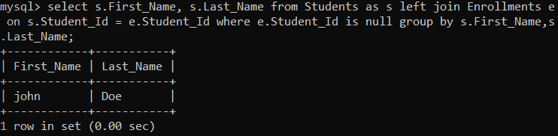

4. retrieve the first name, last name of students, and the names of the courses they are enrolled

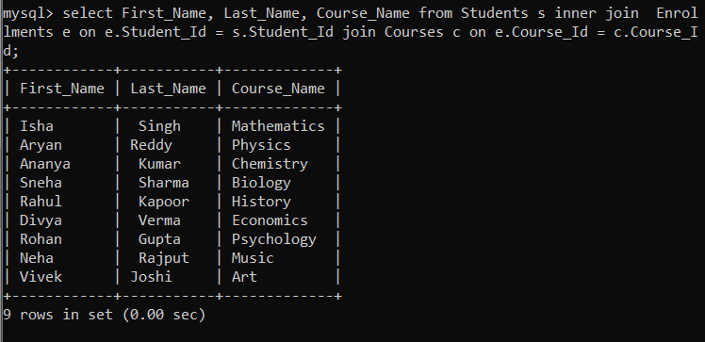

5. list the names of teachers and the courses they are assigned

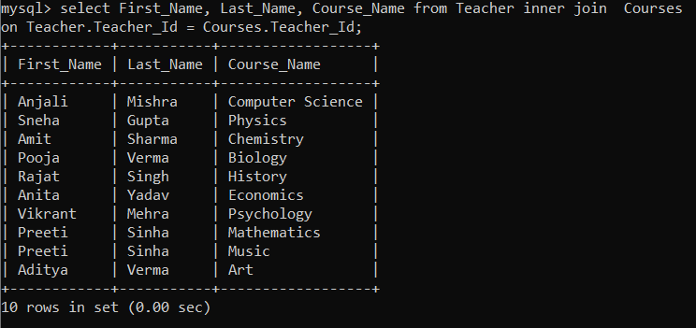

6. list of students and their enrollment dates for a specific course

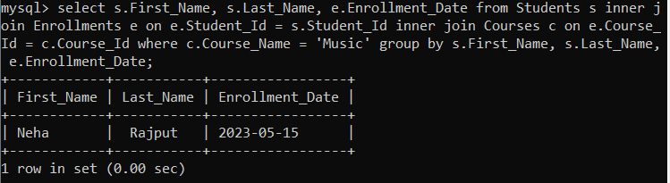

7. the names of students who have not made any payments

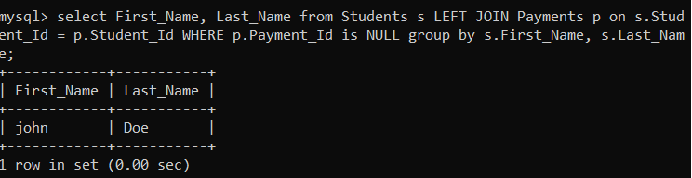

8. identify courses that have no enrollments.

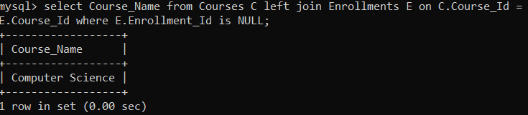

9. students who are enrolled in more than one course

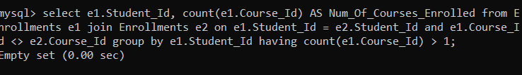

10. teachers who are not assigned to any courses. Use a LEFT JOIN between the "Teacher" table and the "Courses" table and filter for teachers with NULL course assignments

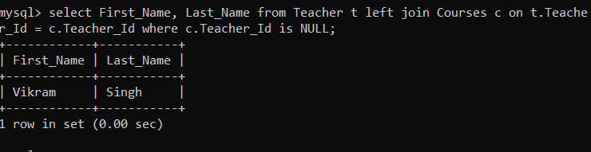

TASK 4

1. calculate the average number of students enrolled in each course.

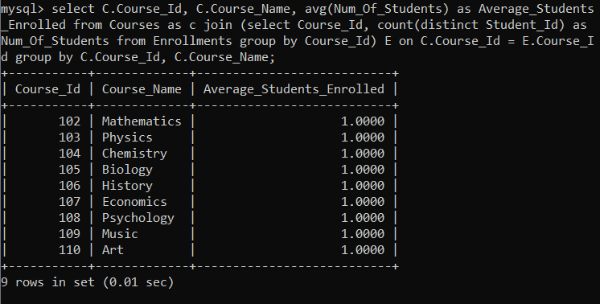

2. the student(s) who made the highest payment.

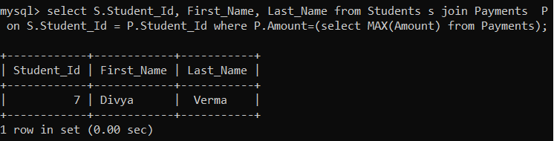

3. list of courses with the highest number of enrollments.

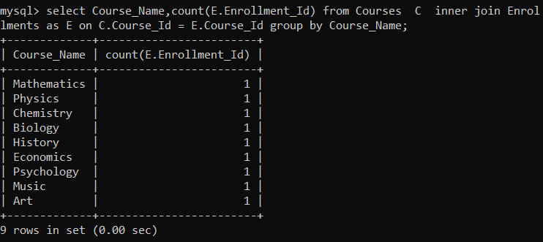

4. the total payments made to courses taught by each teacher

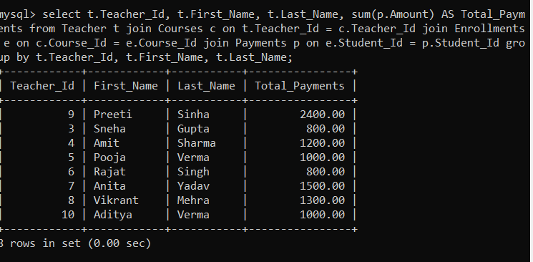

5. students who are enrolled in all available courses

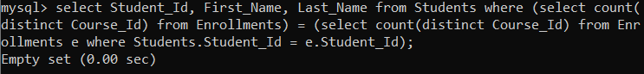

6. the names of teachers who have not been assigned to any courses

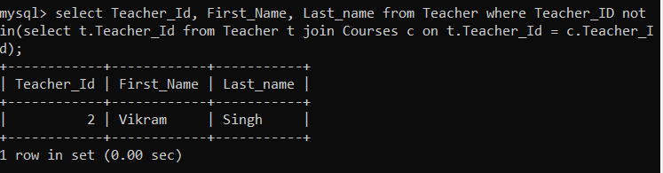

7. the average age of all students

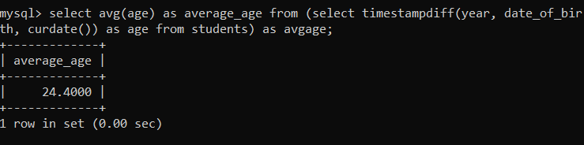

8. Identify courses with no enrollments. Use subqueries to find courses without enrollment records

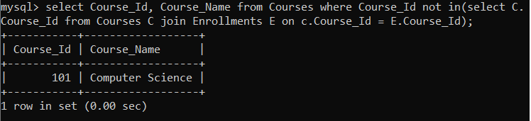

9. the total payments made by each student for each course they are enrolled

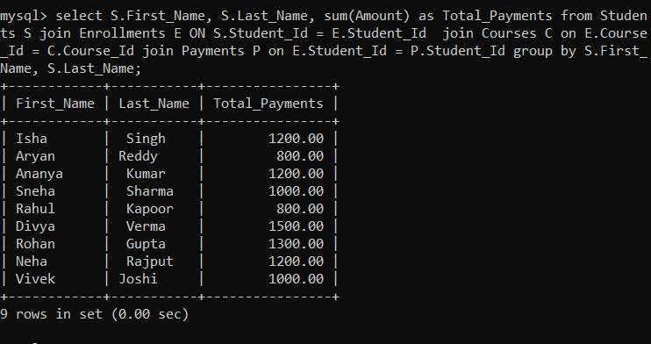

10. students who have made more than one payment.

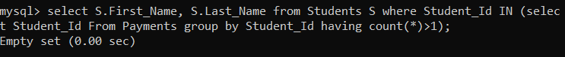

11. SQL query to calculate the total payments made by each student

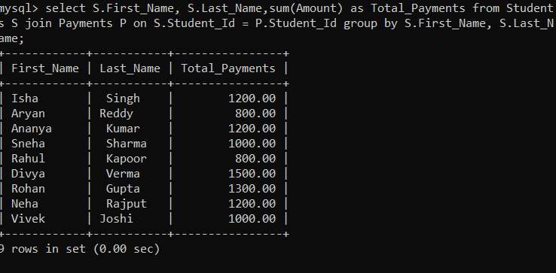

12. a list of course names along with the count of students enrolled in each course

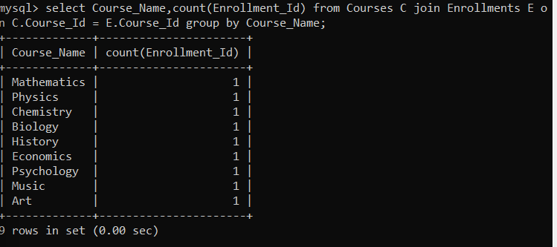

13. the average payment amount made by students.

